Repository:

My Documents/GitHub/radiasoft/rsfriction/examples/MCOOL/all_docs/my_docs

This doc: Comparison of Two Approaches.docs

**Comparison of Two Approaches**

Let us compare two approaches to calculate the transferring of momentum to ion from the electron during flighting of this electron near the ion.

Approach “Guiding Center” (“GC”)

In this case the motion of the electron is described in guiding center system using set of variables  instead “standard” set . These sets are related to the following expressions :



and vice versa:



In these expressions the Larmor radius  and Larmor frequency  are used.

It can be shown [1] that when an electron flies past an ion, the next pulse is transmitted to the latter:



with



It is convenient to define the value



and then



If initially the fixed ion is at the origin (), then these expressions take the following form:



where



Approach “Magnus Expansion” (“ME”)

In this case the transmitted pulse is as follows [1]:



In these formulas the values  are



where 

and



with



It is easy to see that



In the case of the unmovable ion is at the origin () these expressions take the following form:



where



and



with



Some numerical evaluations

Let the unmovable ion be at the origin, i.e. . For the electrons having the same longitudinal velocity , determined by the longitudinal temperature [2,3], one has . For magnetic field  the Larmor frequency equals  so . Results of the numerical simulation for the electrons with transversal temperature  [2,3] is shown on the next Figures for values of :

A close up of text on a white background

Description generated with high confidence 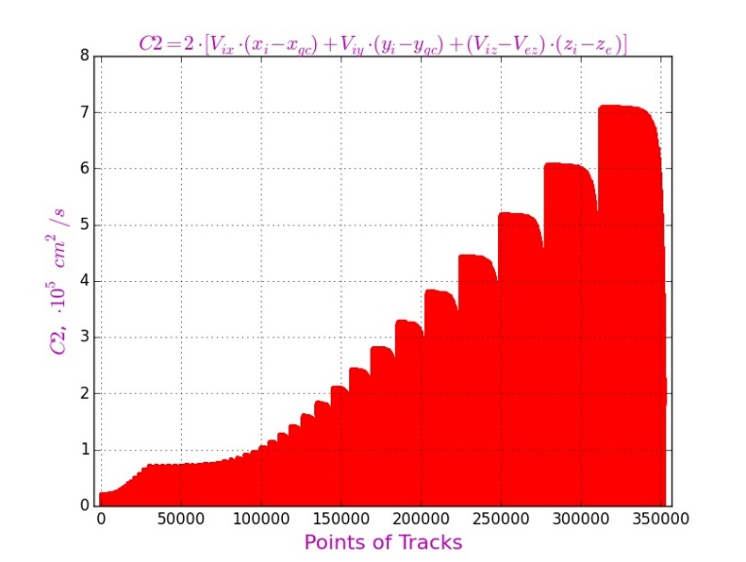

A screenshot of a cell phone

Description generated with high confidence

These Figures shows, that typically (for example, for maximal values)

Then the second and third terms under root for the quantity  are much smaller than the first term, so that



Next Figures shows result of simulation of the values  and , and the comparison of them.

A close up of a piece of paper

Description generated with high confidence A close up of a piece of paper

Description generated with high confidence

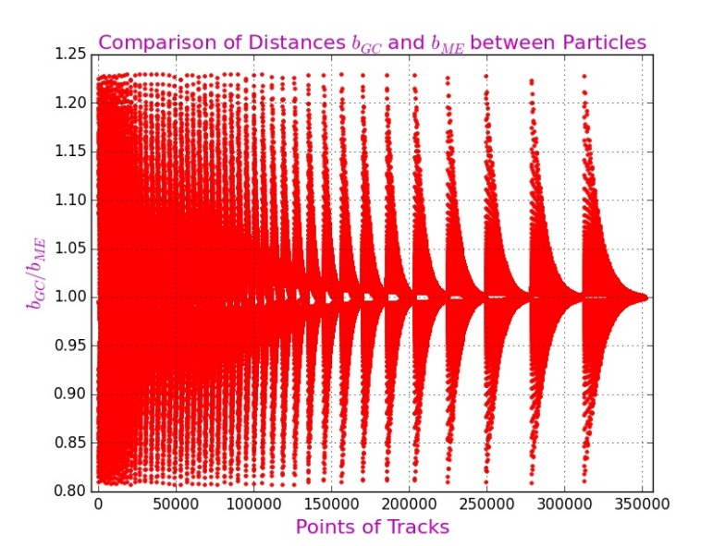

Result of comparison is as follows: the difference between values does not exceed 20%.

To find the transferred momenta let us evaluate the values  and :



and



Next Figures

and since the first term in the expression for  is much greater than the second, then . It means that



In a completely analogous way we obtain that



and





But  and , then



So, in the approximation under consideration for “ME” approach we have the following result:



i.e. expressions for  are in coincide with corresponding values from approach “GC” (!).

It is clearly, that in numerical simulations the calculated values of transferred momenta will differ for both approaches due to real differences between pairs  and ,  and ,  and , and so on.

Comparison of Simulations

Next two pictures show results for transferred momentum in different presentations: in percentages and in logarithmic scale.

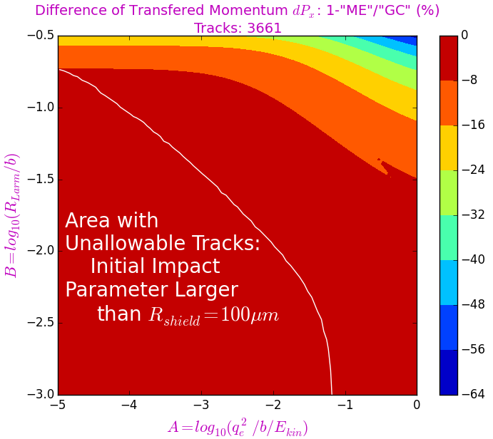 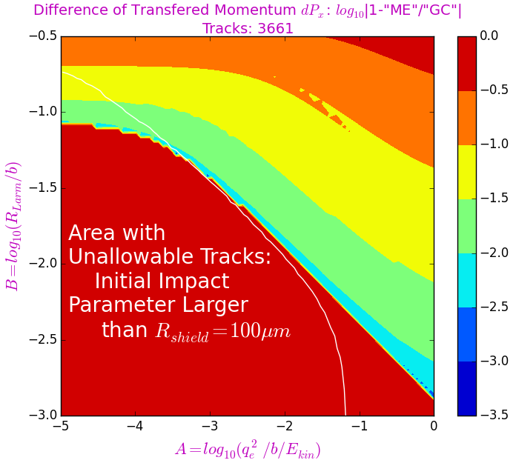

Next figures show the analogous results for transferred momentum .

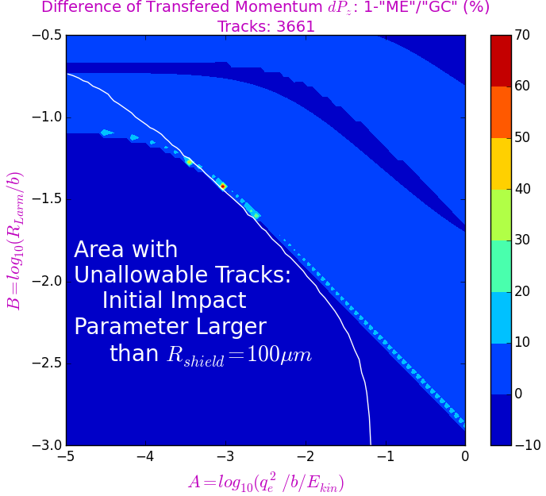 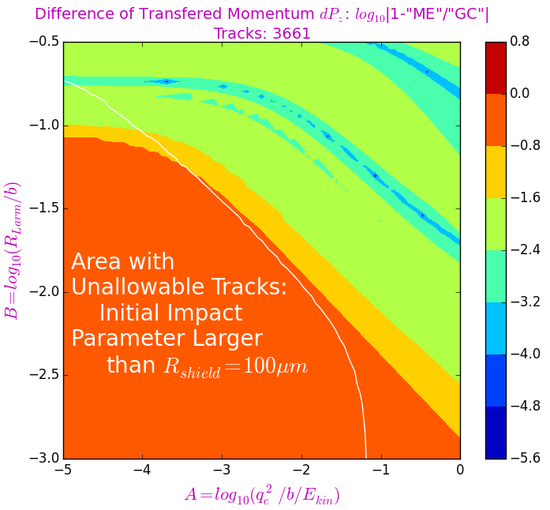

References.

1. David Bruhwiler, Stephen Webb, Dan T. Abell. *A New Approach to Calculating Dynamical Friction for Magnetized Electron Cooling.* Presented at HSC Section Meeting, CERN (Hadron Synchrotron Collective effects), 24 April 2017, Geneva.
2. G.I. Budker et al. *Experimental Investigation of the Electron Cooling*. Preprint BINP 76-33, Novosibirsk, 1976 (In Russian);
3. N.S. Dikansky et al. *Influence of the Sign of the Ion Charge on the Friction Force for Electron Cooling*. Preprint BINP 87-102, Novosibirsk, 1987.